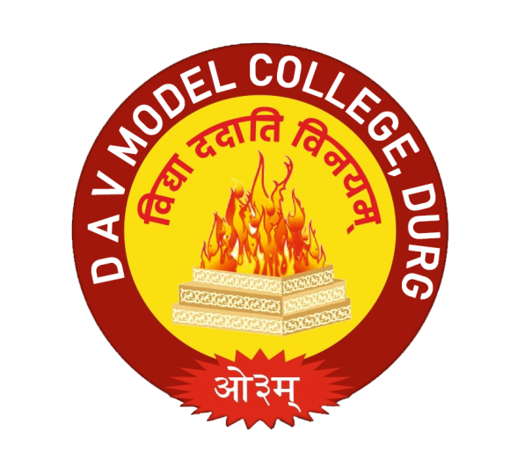

**SESSION 2022-24**

**NAME : FIRST NAME**

**CLASS : B.Ed. 1ST SEMESTER**

**SUBJECT : PEDAGOGY OF LANGUAGE (ENGLISH)**

ARYA NAGAR DURG (C.G.)